**Bind - Caching DNS Local**

Release: 24/03/2012  
Last update: 05/04/2012  
 Number of Updates: 4

**Instalação:**

$ sudo apt-get install bind9

>Servidor Cache DNS

Inserir os endereços IP dos servidores DNS do seu provedor de acesso:

Arquivo: $ sudo nano /etc/bind/named.conf.options

Descomente as linhas 13 a 15 do arquivo

– Insira os endereços IP dos servidores DNS

– Salve e reinicie

$ sudo service bind9 restart ou $ sudo /etc/init.d/bind9 restart

**Para visualizar o conteúdo do Cache DNS:**

» $ sudo rndc dumpdb

O resultado é salvo no arquivo:

$ sudo nano /var/cache/bind/named_dump.db

**Para esvaziar o Cache DNS:**

» $ sudo rndc flush

» $ sudo rndc dumpdb

**Configuração de Servidor DNS Primário - zona direta**

1. Modificar o arquivo de configuração principal do bind

$ sudo nano /etc/bind/named.conf.local

e adicionar:  
#example.com = seu site

zone "example.com" {

type master;

file "/etc/bind/db.example.com";

};

Depois fazer uma copia o arquivo dB.local para o mesmo diretório com o domínio do site.

**$ sudo cp /etc/bind/db.local /etc/bind/db.example.com**

Edit the new zone file /etc/bind/db.example.com change localhost. to the FQDN of your server, leaving the additional "." at the end. Change 127.0.0.1 to the nameserver's IP Address and root.localhost to a valid email address, but with a "." instead of the usual "@" symbol, again leaving the "." at the end.

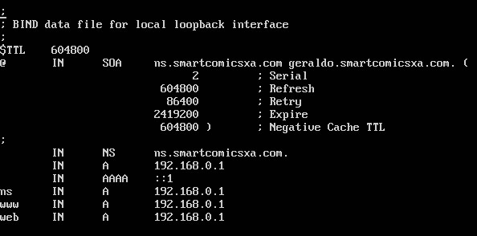

|  |  |
| --- | --- |
| A description... |  |
| Many admins like to use the last date edited as the serial of a zone, such as *2007010100* which is yyyymmddss (where *ss* is the Serial Number) |

Once you have made changes to the zone file **BIND9** needs to be restarted for the changes to take effect:

**sudo service bind9 restart**

**Reverse Zone File**

Now that the zone is setup and resolving names to IP Adresses a *Reverse zone* is also required. A Reverse zone allows DNS to resolve an address to a name.

Edit **/etc/bind/named.conf.local** and add the following:

zone "1.168.192.in-addr.arpa" {

type master;  
 notify no;

file "/etc/bind/db.192";

};

|  |  |
| --- | --- |
| A description... |  |
| Replace *1.168.192* with the first three octets of whatever network you are using. Also, name the zone file /etc/bind/db.192 appropriately. It should match the first octet of your network. |

Now create the /etc/bind/db.192 file:

**$ sudo cp /etc/bind/db.127 /etc/bind/db.192**

Next edit /etc/bind/db.192 changing the basically the same options as /etc/bind/db.example.com:

;

; BIND reverse data file for local loopback interface

;

$TTL 604800

@ IN SOA ns.example.com. root.example.com. (

2 ; Serial

604800 ; Refresh

86400 ; Retry

2419200 ; Expire

604800 ) ; Negative Cache TTL

;

@ IN NS ns.

10 IN PTR ns.example.com.

The *Serial Number* in the Reverse zone needs to be incremented on each change as well. For each *A record* you configure in/etc/bind/db.example.com you need to create a *PTR record* in /etc/bind/db.192.

After creating the reverse zone file restart **BIND9**:

**$ sudo service bind9 restart**